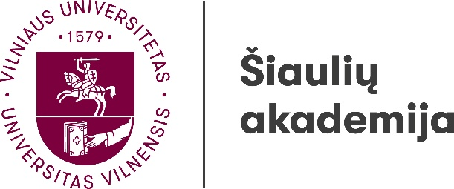

Institute of Regional Development

15th International Interdisciplinary Scientific Conference
THE REGION: HISTORY, CULTURE, LANGUAGE
14th–15th of May, 2026
Šiauliai

A research group “Linguistic, Literary and Cultural Research” organises an international interdisciplinary scientific conference The Region: History, Culture, Language on the 14th–15th of May, 2026.
Researchers of different fields are invited to participate and discuss the subject using different perspectives.

Suggested topics:
- Methodologies and methods in regional research;
- Regions in historical research;
- Cultural and communication memory in the region;
- Regional policy and governance;
- Region in ethnology, anthropology and cultural research;
- Regional identity, mentality and self-awareness;
- Ethnographic peculiarities of regions;
- Linguistic understanding of the region, territorial and social dialects, language specifics;
- Regional literature and regional authors, regions and regionality in literature;
- Traditional and contemporary applied and visual art expression in the region;
- Development opportunities for the design sector in the region;
- Regions in the context of informal art education;
- The specifics of musical folklore in the regions;
- The peculiarities of creation, dissemination and perception of professional music in the regions.

Conference languages: Lithuanian, English.

The conference will be held at the Šiauliai Academy (Vytauto st. 84, Šiauliai) and online via the Microsoft Teams.

The international interdisciplinary scientific conference “The Region: History, Culture, Language” (14th–15th of May, 2026)
The conference participation fee is 30.00 EUR
Institution-receiver: Vilniaus Universitetas
Universiteto g. 3, Vilnius LT-01513
Account number: LT247044060001101392
AB SEB bankas
Gedimino g. 12, Vilnius LT-01103
SWIFT code CBVILT2X
The purpose of the payment (must be written):
Conference № ŠA-2026-05-0006 (participant name, surname) fee.

Registration forms including a summary of the presentation (200–300 words) should be submitted by email: regina.kvasyte@sa.vu.lt till the 17th of April, 2026.
Authors will be informed about the inclusion of their papers into the conference programme till the 27th of April, 2026.

Conference Scientific Committee:

Chairperson – Dr Regina Kvašytė (Vilnius University Šiauliai Academy, Lithuania)
Members:
Dr Juris Ciganovs (Latvian War Museum, Latvia)
Dr Vita Juknevičienė (Vilnius University Šiauliai Academy, Lithuania)
Dr Mihaela Koletnik (Maribor University, Slovenia)
Dr Vladimir Legac (University of Zagreb, Croatia)
Dr Arturs Medveckis (Rīga Technical University Liepāja Academy, Latvia)
Dr Monika Pokorska-Iwaniuk (Adam Mickiewicz University in Poznań, Poland)
Dr Henrihs Soms (Daugavpils University, Latvia)
Dr Anna Stafecka (University of Latvia, Latvia)
Dr Rita Regina Trimonienė (Vilnius University, Lithuania)
Dr Kristīne Vaceka-Ante (Charles University, Czech Republic)
Dr Jolanta Vaskelienė (Vilnius University Šiauliai Academy, Lithuania)

Institute of Regional Development

15th International Interdisciplinary Scientific Conference
THE REGION: HISTORY, CULTURE, LANGUAGE
14th–15th of May, 2026
Šiauliai

REGISTRATION FORM

To be submitted to regina.kvasyte@sa.vu.lt till the 17th of April, 2026.

Name, surname
Organisation
Position
Academic title and degree
Telephone
E-mail
Address
Presentation topic
Summary of the presentation (200–300 words)

Planning to participate: online or face to face

Notes:

