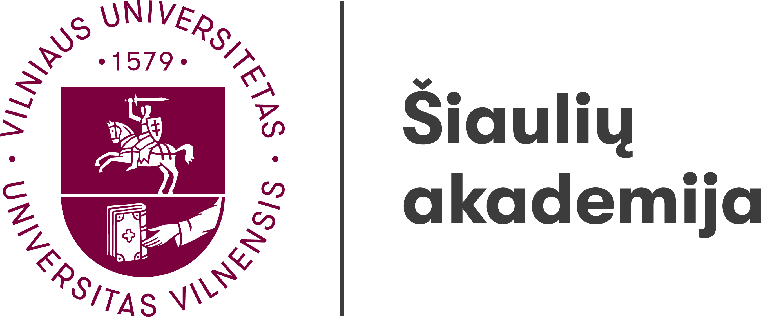

Institute of Regional Development

11th International Interdisciplinary Scientific Conference
THE REGION: HISTORY, CULTURE, LANGUAGE
19th – 20th May 2022
Šiauliai

A research group “Linguistic, Literary, Cultural and Historical Research: the Regional Aspect” organise an international interdisciplinary scientific conference The Region: History, Culture, Language on 19th – 20th May 2022.
Researchers of different fields are invited to participate and discuss the subject from different perspectives.

Suggested topics:
- Methodologies and methods in regional research
- Regions in historical research
- Cultural and communication memory in the region
- Regional policy
- Region in ethnology, anthropology and cultural research
- Regional identity, mentality and self-awareness
- Ethnographic peculiarities of regions
- Linguistic understanding of the region, territorial and social dialects, language specifics
- Regional literature and regional authors, regions and regionality in literature
- Traditional and contemporary applied and visual art expression in the region
- Development opportunities for the design sector in the region
- Regions in the context of informal art education
- The specifics of musical folklore in the regions
- The peculiarities of creation, dissemination and perception of professional music in the regions

Conference languages: Lithuanian, English, Russian.

Information on the mode of the conference (online via the Microsoft Teams or physically face-to-face), also on the participation fee, if the conference is to be held physically face-to-face, will be announced later.
The articles based on the conference presentations are planned to be published in the online journal Acta humanitarica academiae Saulensis (publishing issues are still being coordinated).

Registration forms including a summary of the presentation (200–300 words) should be submitted to regina.kvasyte@sa.vu.lt by the 25th April 2022.
Authors will be informed about the inclusion of their papers into the conference programme by the 5th May 2022.

Conference Scientific Committee:

Chairperson – Dr Regina Kvašytė (Vilnius University Šiauliai Academy, Lithuania)
Members:
Dr Juris Ciganovs (Latvia Military Museum, Latvia)
Dr Dalia Jakaitė (Vilnius University Šiauliai Academy, Lithuania)
Dr Aija Jansone (The Ethnographic Open-Air Museum of Latvia; University of Latvia, Latvia)
Dr Vita Juknevičienė (Vilnius University Šiauliai Academy, Lithuania)
Dr Mihaela Koletnik (Maribor University, Slovenia)
Dr Vladimir Legac (University of Zagreb, Croatia)
Dr Henrihs Soms (Daugavpils University, Latvia)
Dr Anna Stafecka (University of Latvia, Latvian Language Institute, Latvia)
Dr Reda Šatūnienė (Vilnius University Šiauliai Academy, Lithuania)
Dr Rytis Urniežius (Vilnius University Šiauliai Academy, Lithuania)

Institute of Regional Development

11th International Interdisciplinary Scientific Conference
THE REGION: HISTORY, CULTURE, LANGUAGE
19th–20th May 2022
Šiauliai

REGISTRATION FORM

To be submitted to regina.kvasyte@sa.vu.lt by the 25th April 2022.

Name, surname
Organisation
Position
Academic title and degree
Telephone
E-mail
Address
Presentation topic
Summary of the presentation (200–300 words)

Required equipment for the presentation

Notes:

